CENWP-OD-B 27 September 2010

MEMORANDUM FOR THE RECORD

SUBJECT: Dead chinook at Bonneville’s Adult Fish Facility (AFF).

On 27 September at approximately 1030, CRITFC researchers called Project Fisheries to report two dead chinook in the AFF. The fish were discovered on the Valve 15 return pool drain trash rack while CRITFC was cleaning off debris. Both fish had been dead for multiple days. The 95 cm chinook had some exposed flesh, but that was likely from pulling the carcass off the trash rack. The 66 cm tagged chinook had previously been sampled by CRITFC in days prior to discovery. The fish were disposed of down drain valve 15 in the AFF at approximately 1100. Information collected is provided below:

- Species – two chinook
- Origin – unclipped
- Length – 66 cm; 95 cm
- Marks and tags – 3D9.1C2D416328; none
- Marks and Injuries found on carcass – N/A
- Cause and Time of Death – Unknown
- Future and Preventative Measures – N/A

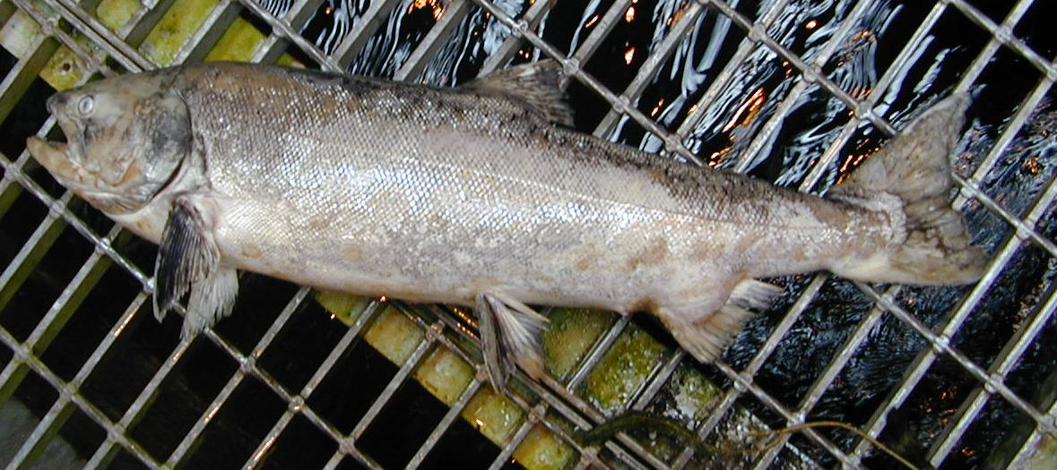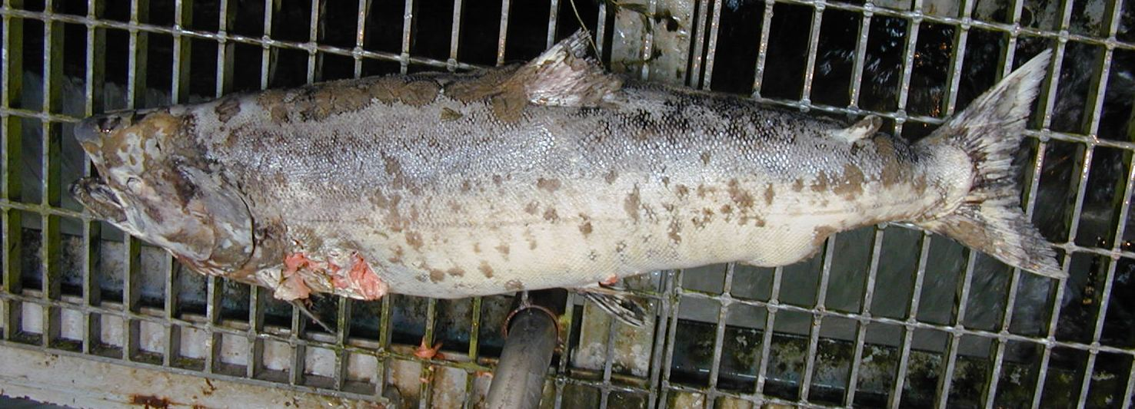

Bonneville Fisheries

